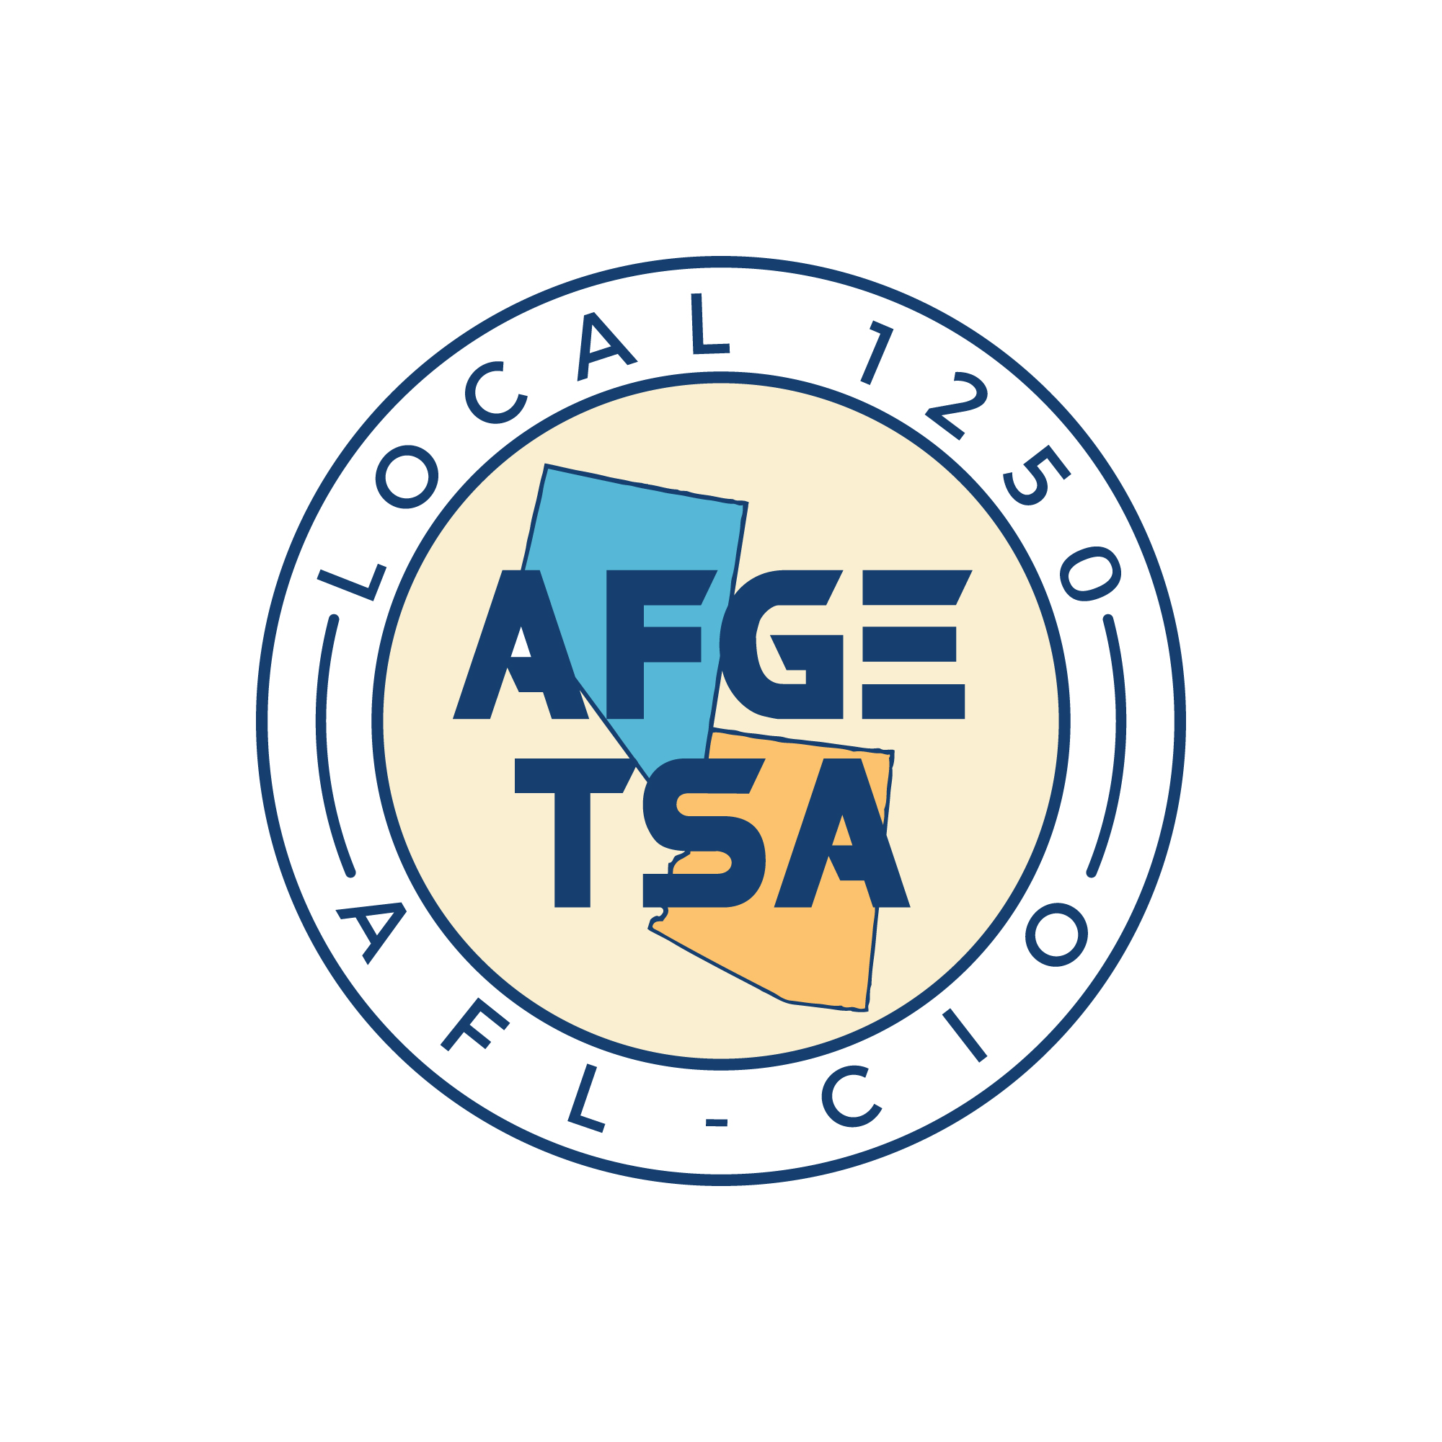 AFGE TSA Local 1250 

Meeting Minutes

January 30, 2025
Call to Order
The meeting was called to order at 13:36 PM PST / 14:36 AM MST by Local Secretary Jovan Petkovic via Zoom Platform and in person at RNO River Conference Room.
Roll Call
Roll call was performed, and the following Executive Board members were present:
Present:
- Local President, Juan Casarez
- Local Treasurer, Diane Rodriguez
- Local Secretary, Jovan Petkovic
- Arizona Chief Steward, Javier Casarez
- Nevada Chief Steward, Marcos Crespo
Not Present:
- Local Nevada Vice President, Becky Cooper
Additional members were present as per the attached sign-in sheet.
Approval of Previous Meeting Minutes
Secretary Jovan Petkovic read the minutes from the previous meeting held on December 19, 2024. A motion to approve the minutes was made by Javier Casarez, seconded by Marley Margaillan, and passed with no amendments.
Agenda
- Reading of Financial Reports
  - Treasurer Diane Rodriguez provided a comprehensive financial report covering all activities in December 2024.
    - Significant expenses included per diem, meeting expenses, uniform purchases, and officer stipends. The full financial breakdown was shared. Questions were invited but none were raised, signaling satisfaction among members.
- Political Action Updates:
  - Preparation for the upcoming Legislative Conference in February 2025.
  - Efforts to advocate for full Title 5 protections for TSA employees.
  - Local Political Coordinator Pascal Contreras will coordinate strategy sessions in early January.
- Council 100 Leadership Training:
  - Reviewed pitfalls members commonly make with writing statements and the lack of invoking Weingarten Rights in a timely manner. Several items discussed which were identified in the training.
New Business:
Announcements made of Arizona Vice President Robert Strength to have resigned from his position due to promotion to K9 Handler. The local wishes him well in his future endeavors. Local Political Coordinator Pascual Contreras, likewise, resigned, citing personal reasons. The local wishes him well in his future endeavors.
Treasurer Diane Rodriguez presented planning of member engagement events soon, to include a social gathering event at a venue named “Main Event”; and lunch & learns at various airports throughout the local’s area to facilitate member engagement and benefits education.
Adjournment
A motion to adjourn was made at 13:59 PM PST / 14:59 PM MST by Jovan Petkovic, seconded by Marly Margaillan, and carried unanimously.
Minutes Submitted By:
Jovan Petkovic, Local Secretary
Minutes Approved By:
Juan Casarez, Local President

