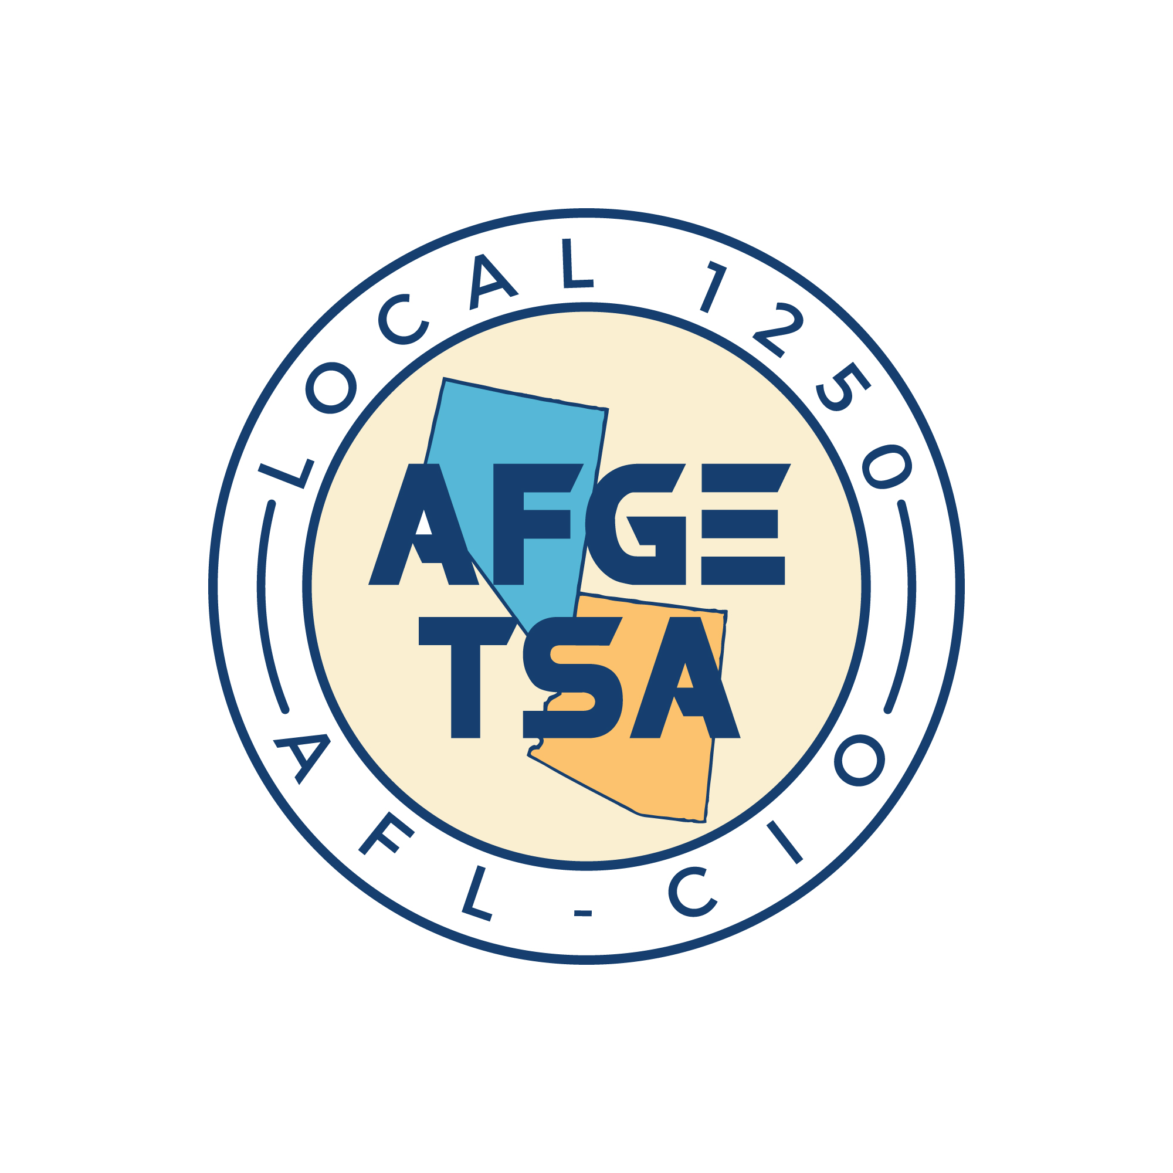 AFGE TSA Local 1250 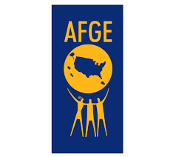

Meeting Minutes

March 20, 2024

- Call to order
Secretary Jovan Petkovic called to order the regular meeting of the AFGE Local 1250 at 10:08AM PST on March 20, 2024, at Reno-Tahoe International Airport, via Zoom Meeting Platform and in-person.
- Roll call
Roll call was performed, present from the Executive Board are Juan Casarez, Local President, Diane Rodriguez, Treasurer; Jovan Petkovic, Secretary; Robert Strength, AZ Vice President; Becky Cooper, Nevada Vice President; Pascual Contreras, Political Coordinator; and additional members. Please see attached sign in sheet.
Secretary Jovan Petkovic read the meeting minutes from the last member meeting, held on February 27, 2024. Minutes were presented to the body. Approval of minutes from last meeting was performed. No addition, corrections, or amendments were made to the meeting minutes. Member Mike Palumbo entered motion to approve the minutes. Motion second by Member Eric Hatcher. Motion passed and Minutes approved.
- Agenda
- Review of New AFGE/TSA Contract
  - Summary of changes
  - Secretary Jovan Petkovic detailed expansions to union representation rights, benefits, and processes under the new tentative contract. Members await DHS approval before it takes effect within 60 days.
  - Summary of changes in new contract were presented to the members present.
  - Summary of changes attached to the minutes.

- Review of Legislative Conference Meetings
  - Local representatives met with Members of Congress and Staffers regarding employee working conditions, request for Title V support, and provided samples of Management Directive issues causing removals from service (fit for duty).
  - Political engagement after Congress meetings revealed lack of awareness on TSO issues. Members must educate representatives through visits and pre-written letters on AFGE.org to improve conditions.

- Review of Member Benefits
  - Secretary Jovan Petkovic demonstrated the vast resources on afge.org and unionplus.org for members' financial, educational, travel and other discounts. Immediate families also benefit through realtors, insurers and more.

- Review of Workers Compensation Claim Process
  - What to do when injured at work, or experiencing allergic reactions?
    - CA1 or CA2
    - TSA Form 2400
    - TSA Form 2401
  - Secretary Jovan Petkovic explained timely reporting of injuries through forms 2400, 2401 and filing CA1 or CA2.
  - President Juan Casarez advises following up conversations in email to establish a paper trail for claims.

- Open Business
  - No new business was presented by the body.

      - Member Eric Hatcher entered motion to adjourn the meeting. Motion passed.
  - Adjournment
Secretary Jovan Petkovic adjourned the meeting at 11:15PM PST.
Minutes submitted by: Jovan Petkovic, AFGE Local 1250 Secretary
Minutes approved by: Juan Casarez, AFGE Local 1250 President

